Storing Extracted Nutritional Data in Tables

Week 5

February 26, 2024

Divyanshu

Contents

Objective 3

Implementation Overview 3

AWS Textract Configuration 3

Image Processing 3

Accuracy Calculation 3

Nutritional Information Extraction 3

Results and Output 3

Image Analysis 3

Image 1 – *21040_Dairygold Original - 63_ Fat Blended Spread_back* 3

Image 2 – *21046_Centra Light Irish Milk_Nutritional Info* 4

Image 3 – *21080_Hellmann_s Light Mayonnaise_Nutritional Information_600g_Glass _ Plastic* 5

Image 4 – *21124_Avonmore Low Fat Super Milk_Back* 6

Image 5 – *21260_Weetabix Original_Nutritional Info* 7

Image 6 – *21567_Glenisk Organic Kids Bio No Added Sugar Vanilla Yogurt_Back (1)* 9

Image 7 – *21725_Lucozade Sport Orange_Nutritional Information_750ml_Plastic* 9

Image 8 – *22548_Tesco Bran Flakes_750g_Nutritional Information_Paper _ Board* 10

Image 9 – *Kellogg_s Bran Flakes_Nutritional Info* 12

# Objective

The objective of this report is to extract text from food nutrition labels using the AWS Textract tool, store the information in a CSV file, and evaluate the accuracy of the extracted text compared to ground truth data using the Levenshtein distance algorithm. Additionally, The report also involves highlighting errors in the extracted text.

# Implementation Overview

## AWS Textract Configuration

The AWS Textract client is configured with appropriate AWS credentials, including the access key ID and secret access key. The Textract client is set to operate in the 'us-east-1' region.

## Image Processing

Images are read as byte arrays using the read_image_as_bytearray function. The Textract tool is used to detect document text in the images, and the resulting text and confidence scores are extracted.

## Accuracy Calculation

The Levenshtein distance algorithm is employed to calculate the accuracy of the extracted text compared to ground truth data. The calculate_accuracy_and_errors function is used for this purpose.

## Nutritional Information Extraction

The extract_nutritional_info function is responsible for extracting nutritional information from the text. It uses predefined nutrient keywords and searches for them in the text to extract corresponding values and confidence scores.

## Results and Output

The extracted text, Levenshtein accuracy, and errors are printed for each image. Additionally, the nutritional information is extracted and stored in a CSV file for further analysis.

## Image Analysis

### Image 1 – *21040_Dairygold Original - 63_ Fat Blended Spread_back*

#### Output:

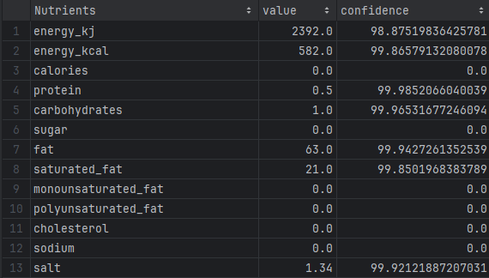

### Image 2 – *21046_Centra Light Irish Milk_Nutritional Info*

#### Output:

### Image 3 – *21080_Hellmann_s Light Mayonnaise_Nutritional Information_600g_Glass _ Plastic*

### Image 4 – *21124_Avonmore Low Fat Super Milk_Back*

* Salt was read as **0.16** instead of **0.1g.**
* Energy wasn’t extracted.

#### Output:

### Image 5 – *21260_Weetabix Original_Nutritional Info*

* Energy in kJ calculated as **1514.**
* Carbohydrates as **26** instead of **69.**
* Fibre extracted as **12** instead of **10** which is protein’s value.
* Niacin extracted as **0.8** instead of **14mg.**
* Folic acid extracted as **0.6** instead of **170µg.**
* Iron extracted as **100** instead of **12mg.**

#### Output:

### Image 6 – *21567_Glenisk Organic Kids Bio No Added Sugar Vanilla Yogurt_Back (1)*

#### Output:

### Image 7 – *21725_Lucozade Sport Orange_Nutritional Information_750ml_Plastic*

* Nothing was extracted.

#### Output:

### Image 8 – *22548_Tesco Bran Flakes_750g_Nutritional Information_Paper _ Board*

* Energy kcal calculated as **358.75.**
* Niacin wasn’t extracted.
* Vitamin b6 wasn’t extracted.
* Folic acid wasn’t extracted.
* Vitamin b12 wasn’t extracted.

#### Output:

### Image 9 – *Kellogg_s Bran Flakes_Nutritional Info*

* Energy kcal calculated as **362.57.**

#### Output:

